DESIGN PATTERNS AND PRINCIPLES
NAME : L.VATSHITHA
REG:23BCE8936
1) Singleton Pattern
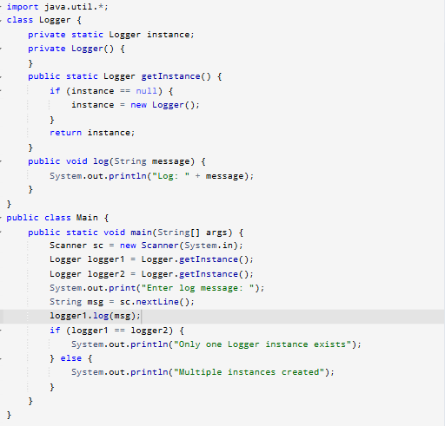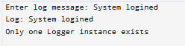

2) Factory Method Pattern
